Spearman rank correlation: AUDUSD and NZDUSD
Method 02 / daily log returns / Alpari D1 full available history

Study setup
Logical pair: AUDUSD , NZDUSD
Broker symbols: AUDUSD_i , NZDUSD_i
Snapshot: 2026-11-03_majors_alpari_D1
Timeframe: D1
Matched return window: 1999-01-05 to 2026-11-02 (UTC bar dates)
Matched return count n: 7202
Dropped unfinished last bar dated 2026-11-03 UTC after a tick-volume check against the prior complete day.
Complete matched rows (CSV): AUDUSD-NZDUSD_Spearman_D1.csv
Complete matched rows (HTML table): AUDUSD-NZDUSD_Spearman_D1_data.html

Method carried forward
Spearman rho is Pearson correlation on the ranks of matched daily log returns of close, ln(close_t / close_t-1), in the broker quote direction. Ties use average ranks. Quotes are not inverted. rho is symmetric under swap of the two symbols. rho = 0 means no consistent rank-order link in this sample; it does not mean no link of any kind. The score is not a cause, not a lead, and not a trading signal. Daily rows are not independent draws, so the two-sided p-value and approximate Fisher interval are reported and treated as secondary to rho. Same-sample Pearson r is shown only as a side check; a large rho minus r gap can flag outliers or a non-straight link.

Results
Spearman rho: 0.805371
Two-sided p-value: 0
Approximate 95% Fisher interval: [0.797102, 0.813338]
Same-sample Pearson r: 0.828722
rho minus r: -0.023351

Conclusion
Over 7202 matched daily log-return rows for AUDUSD and NZDUSD (broker quote directions unchanged), Spearman rho is 0.8054 (positive, strong rank-order association in this sample). Approximate 95% Fisher interval: [0.7971, 0.8133]. Same-sample Pearson r is 0.8287 (rho minus r = -0.0234). Two-sided p under the usual independent-ranks model is 0; that model does not match linked daily FX returns, so treat p as secondary. This does not establish cause, lead-lag, or a lasting trading rule.

Charts
Daily closes

Daily log returns
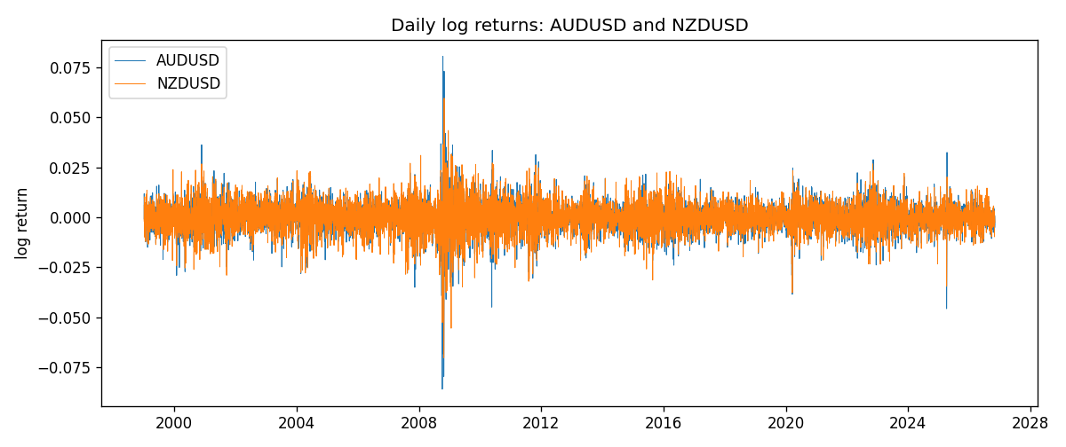
Log-return scatter
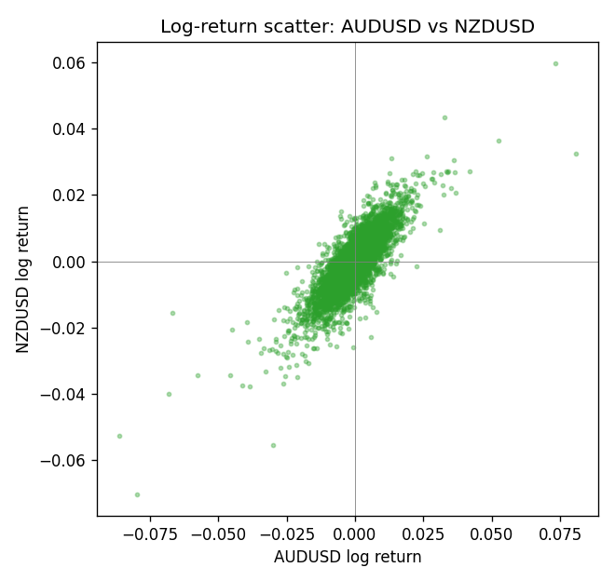
Rank-rank scatter
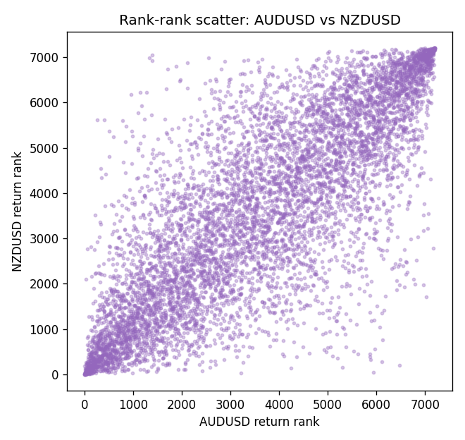

Data report
Every matched row that entered Spearman rho is stored in the sibling CSV named AUDUSD-NZDUSD_Spearman_D1.csv. That file is the complete data archive for redrawing charts. Embedding all rows as a Word table is impractical at this length; the Word file holds the column list, column summaries, and the first and last 15 matched rows.
Columns: time, AUDUSD_open, NZDUSD_open, AUDUSD_high, NZDUSD_high, AUDUSD_low, NZDUSD_low, AUDUSD_close, NZDUSD_close, AUDUSD_tick_volume, NZDUSD_tick_volume, AUDUSD_spread, NZDUSD_spread, AUDUSD_real_volume, NZDUSD_real_volume, AUDUSD_log_return, NZDUSD_log_return
Column summaries (matched calculation rows)
column | count | mean | std | min | 25% | 50% | 75% | max
AUDUSD_open | 7202 | 0.75190973 | 0.13530408 | 0.4785 | 0.6610275 | 0.731395 | 0.8089525 | 1.10284
NZDUSD_open | 7202 | 0.65620671 | 0.10825448 | 0.3913 | 0.5910925 | 0.6683 | 0.724695 | 0.88218
AUDUSD_high | 7202 | 0.75595988 | 0.13586572 | 0.4878 | 0.6647 | 0.734725 | 0.81501 | 1.10795
NZDUSD_high | 7202 | 0.66012182 | 0.1087492 | 0.3961 | 0.5946275 | 0.67189 | 0.7292675 | 0.88421
AUDUSD_low | 7202 | 0.74785283 | 0.13461673 | 0.4775 | 0.6577 | 0.727385 | 0.8042 | 1.0975
NZDUSD_low | 7202 | 0.6525168 | 0.10784895 | 0.3897 | 0.587955 | 0.66406 | 0.72082 | 0.87988
AUDUSD_close | 7202 | 0.75195766 | 0.13528533 | 0.4786 | 0.6611925 | 0.731645 | 0.809065 | 1.10169
NZDUSD_close | 7202 | 0.65627751 | 0.10825012 | 0.3907 | 0.59141 | 0.668305 | 0.7249175 | 0.8822
AUDUSD_tick_volume | 7202 | 77337.3 | 138128.78 | 109 | 5435.5 | 43320 | 71312.25 | 1234623
NZDUSD_tick_volume | 7202 | 68561.899 | 123036.41 | 17 | 5505.5 | 33822 | 58470.25 | 1127682
AUDUSD_spread | 7202 | 30.821161 | 16.887481 | 0 | 13 | 30 | 50 | 50
NZDUSD_spread | 7202 | 30.366287 | 25.672101 | 0 | 9 | 17 | 50 | 80
AUDUSD_real_volume | 7202 | 5.2413627e+09 | 1.253718e+11 | 0 | 0 | 0 | 0 | 3.811512e+12
NZDUSD_real_volume | 7202 | 1.6659405e+10 | 8.488719e+10 | 0 | 0 | 0 | 0 | 2.705649e+12
AUDUSD_log_return | 7202 | 2.237e-05 | 0.00754318 | -0.08602525 | -0.00386318 | 0.00028132 | 0.00415217 | 0.0806166
NZDUSD_log_return | 7202 | 5.13e-06 | 0.00764596 | -0.07027433 | -0.00426304 | 0.00021271 | 0.00457975 | 0.05966839
First 15 matched rows (selected columns)
time | AUDUSD_close | NZDUSD_close | AUDUSD_log_return | NZDUSD_log_return | AUDUSD_tick_volume | NZDUSD_tick_volume
1999-01-05 | 0.6215 | 0.5372 | -0.00080418179 | -0.0018597736 | 1103 | 748
1999-01-06 | 0.6289 | 0.5383 | 0.011836351 | 0.0020455609 | 1412 | 823
1999-01-07 | 0.6345 | 0.5417 | 0.0088650256 | 0.0062963171 | 1468 | 878
1999-01-08 | 0.6347 | 0.5414 | 0.00031515916 | -0.00055396548 | 1225 | 668
1999-01-11 | 0.6393 | 0.547 | 0.0072213815 | 0.010290425 | 1318 | 681
1999-01-12 | 0.6362 | 0.5441 | -0.0048608485 | -0.0053157489 | 1908 | 793
1999-01-13 | 0.6312 | 0.5387 | -0.0078902098 | -0.0099742238 | 1829 | 1050
1999-01-14 | 0.6295 | 0.5386 | -0.002696916 | -0.00018564931 | 1593 | 1137
1999-01-15 | 0.634 | 0.5382 | 0.007123101 | -0.00074294208 | 1604 | 1124
1999-01-18 | 0.6346 | 0.5372 | 0.00094592471 | -0.0018597736 | 1430 | 1022
1999-01-19 | 0.6392 | 0.5382 | 0.0072225153 | 0.0018597736 | 1733 | 1389
1999-01-20 | 0.64 | 0.5404 | 0.0012507819 | 0.0040793678 | 1901 | 1678
1999-01-21 | 0.6405 | 0.5426 | 0.00078094498 | 0.0040627941 | 1946 | 1599
1999-01-22 | 0.6327 | 0.5361 | -0.012252745 | -0.012051689 | 1875 | 1328
1999-01-25 | 0.6302 | 0.5342 | -0.0039591468 | -0.0035504102 | 1413 | 1035
Last 15 matched rows (selected columns)
time | AUDUSD_close | NZDUSD_close | AUDUSD_log_return | NZDUSD_log_return | AUDUSD_tick_volume | NZDUSD_tick_volume
2026-10-13 | 0.69821 | 0.56127 | 0.0035007712 | 0.0047326165 | 34335 | 27958
2026-10-14 | 0.69715 | 0.55918 | -0.0015193215 | -0.0037306483 | 43650 | 37319
2026-10-15 | 0.69191 | 0.56185 | -0.0075447063 | 0.0047634855 | 50656 | 43714
2026-10-16 | 0.69426 | 0.56509 | 0.0033906408 | 0.0057501001 | 40991 | 35806
2026-10-19 | 0.6978 | 0.56616 | 0.0050859986 | 0.0018917133 | 37273 | 32069
2026-10-20 | 0.70022 | 0.56827 | 0.0034620426 | 0.0037199341 | 38736 | 34470
2026-10-21 | 0.70275 | 0.57003 | 0.0036066384 | 0.0030923331 | 36307 | 30020
2026-10-22 | 0.70186 | 0.56815 | -0.0012672558 | -0.0033035227 | 43496 | 39159
2026-10-23 | 0.70353 | 0.56991 | 0.0023765656 | 0.0030929853 | 39675 | 33693
2026-10-26 | 0.70128 | 0.56826 | -0.0032032829 | -0.0028993932 | 35142 | 30716
2026-10-27 | 0.70245 | 0.56811 | 0.0016669876 | -0.00026399852 | 34625 | 32660
2026-10-28 | 0.70533 | 0.56261 | 0.0040915541 | -0.0097283914 | 46279 | 42740
2026-10-29 | 0.70245 | 0.56296 | -0.0040915541 | 0.00062190714 | 45705 | 40247
2026-10-30 | 0.70316 | 0.56307 | 0.0010102376 | 0.00019537668 | 42925 | 39305
2026-11-02 | 0.69971 | 0.56161 | -0.0049184984 | -0.0025962955 | 41137 | 35347

